A000-EUR-Anatolia-Hittite-Male Figure with metal Mallet-Terra cotta-1100 BCE

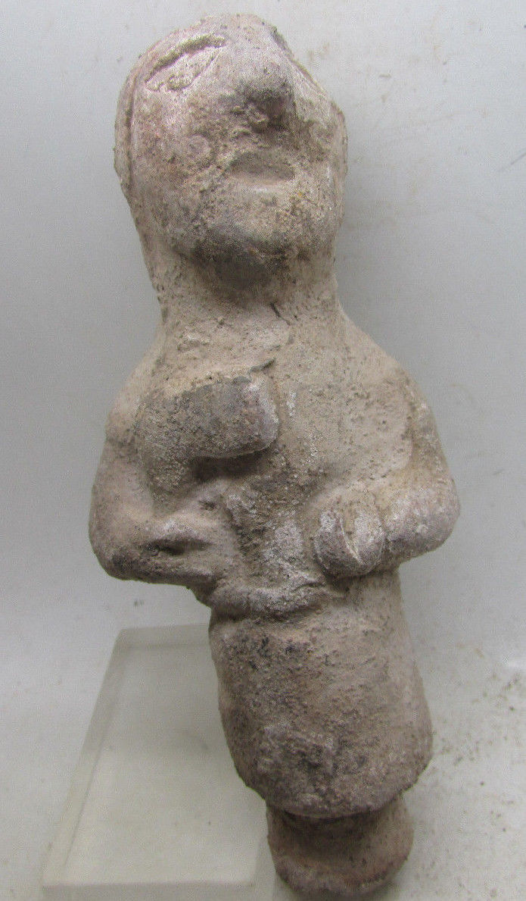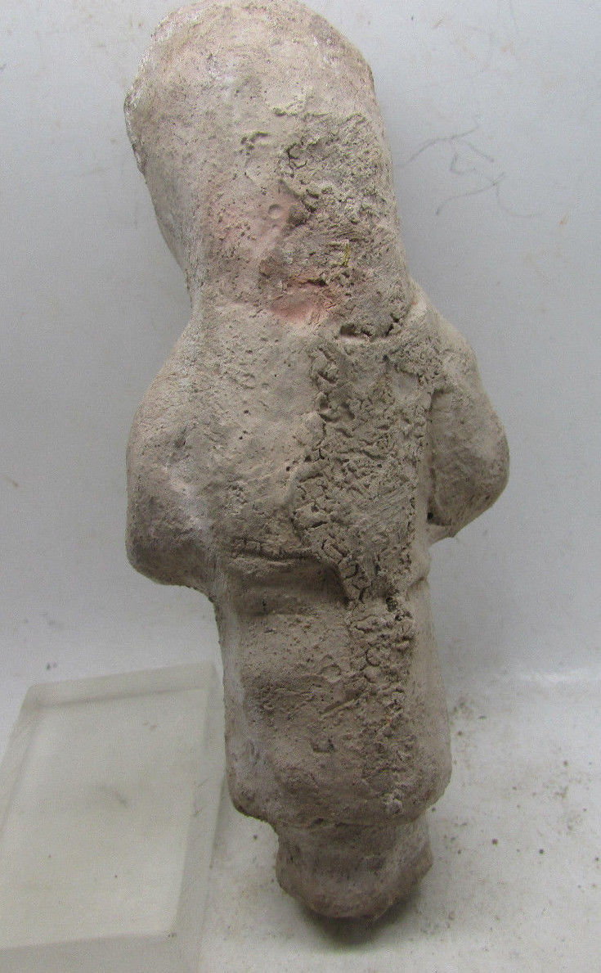

**Case no.:**

**Accession Number:**

**Formal Label:** Anatolia-Hittite-Male Figure with metal Mallet-Terra cotta-1100 BCE

**Display Description:**

**LC Classification:**

**Date or Time Horizon:**

**Geographical Area:**

**Map:**

**GPS coordinates:**

**Cultural Affiliation:**

**Media:** Terra cotta

**Dimensions:** H 11.4 cm

**Weight:**

**Condition: rare**

**Provenance:**

Michael Davies

2 hanover court

Didcot

Oxfordshire

ox11 8nu

United Kingdom

Phone:07948|616659

Email:mike_d456@live.co.uk

**Discussion:**

**References:**